Submitted by:

Murali Satya Pavan Androthu

Candidate ID:105064./

Report – Calendar Application

Course Code: <CODE>



Version Number:

Team Members :

Team No:

Module: Model Based System Engineering

|  |  |  |  |  |  |
| --- | --- | --- | --- | --- | --- |
| **Ver. Rel. No.** | **Release Date** | **Prepared. By** | **Reviewed By** | **Approved By** | **Remarks/Revision Details** |
|  |  |  |  |  |  |
|  |  |  |  |  |  |
|  |  |  |  |  |  |
|  |  |  |  |  |  |
|  |  |  |  |  |  |

**Document History**

Submitted by:

Murali Satya Pavan Androthu

Candidate ID:105064

**Table of contents**

|  |  |  |
| --- | --- | --- |
| **Chapter no** | **content** | **Page no.** |
| 1 | Introduction  1.1 Overview  1.2 Problem statement | 1 |
| 2 | Goals | 2 |
| 3 | Requirements | 3 |
| 4 | Test Plan | 4-6 |
| 5 | Test Cases | 7 |
| 5 | Expected Result | 8-9 |

**CHAPTER 01**

**INTRODUCTION**

**1.1 OVERVIEW**

The main aim of the project is to perform operations like finding the day for a given date and displaying entire year calendar for a given year and displaying certain month for giving particular month and year. Generally all the calendars are designed to perform tasks like displaying the year’s calendar by giving certain year as an input. But, this project came with an extra feature that displays the day by giving the date month and year in a well formatted type. This mini project on Calendar in C programming language is a console application. In this project you can find out the day corresponding to a given date and view the days and dates corresponding to a particular month and year.

**1.2 PROBLEM STATEMENT**

It is hard to find out the day corresponding to a given month and year and a little complicated to find the month calendar by giving month and year, so here with a simple c program you can find out the day for a given date and view the entire year calendar by entering the year and view the days and dates corresponding to a particular month and year.

**CHAPTER 02**

**GOALS**

1. To find the day by entering the day, month and year. For example, if you enter day = 28, month = 06 and year = 1998, it displays the day ‘Sunday’.

2.To find the month calendar by entering the month and year. For example, if you enter month = 09 and year = 2020, it gives you the overall september month of 2020.

3.To find the entire year calendar by entering the year.It displays a nicely formatted calendar of every month of that particular year.

4.If you want to exit from the loop choose option 4 to exit and it displays “bye!!”.

**CHAPTER 03**

**REQUIREMENTS**

**Software**: Code::Blocks IDE Version 20.03.

**Operating System**: Windows.

### Header Files Required:

● **<stdio.h>** (Standard input-output header) : Used to perform input and output operations in C.

● **<conio.h>** (Console input-output header) : Perform console input and console output operations like clrscr() to clear the screen and getch() to get the character from the keyboard.

● **<stdlib.h>** (Standard library header) : Perform standard utility functions.

● **<windows.h>**:It is a windows specific header file used in C programming which contains declarations for all the functions in windows API.

**Functional Requirements**:

● Find the day:Add Records:To find the day by entering the day, month and year.For example, if you enter day = 28, month = 06 and year = 1998, it displays the day ‘Sunday’.

● Find the month:To find the month calendar by entering the month and year. For example, if you enter month = 09 and year = 2020, it gives you the overall september month of 2020.

● Find the year calendar:To find the entire year calendar by entering the year.It displays a nicely formatted calendar of every month of that particular year

● Exit:If you want to exit from the loop choose option 4 to exit and it displays “bye!!”.

**CHAPTER 04**

**Test plan**

**4.1 Introduction:**

The purpose of testing is to discover errors. Testing is the process of trying to discover every conceivable fault or weakness in a work product. It provides a way to check the functionality of components, sub-assemblies, assemblies and/or a finished product.Software system meets its requirements and user expectations and does not fail in an unacceptable manner.

**4.2 Features to be tested:**

|  |  |
| --- | --- |
| **S.No** | **Test Objective** |
| 1. | To check if the day printed correctly or not. |
| 2. | To check if the calendar is printed for a particular month is correct or not. |
| 3. | To check whether the entire calendar is printed or not,if printed,then check if the calendar is correct or not. |

**4.3 Testing Levels**

**Unit Testing:**

Unit testing involves the design of test cases that validate that the internal program logic is functioning properly, and that program inputs produce valid outputs. All decision branches and internal code flow should be validated. It is the testing of individual software units of the application .It is done after the completion of an individual unit before integration. This is a structural testing, that relies on knowledge of its construction and is invasive. 56 Unit tests perform basic tests at component level and test a specific business process, application, and/or system configuration. Unit tests ensure that each unique path of a business process performs accurately to the documented specifications and contains clearly defined inputs and expected results.

**Integration Testing:**

Integration tests are designed to test integrated software components to determine if they actually run as one program. Testing is event driven and is more concerned with the basic outcome of screens or fields. Integration tests demonstrate that although the components were individually satisfied, as shown by successfully unit testing, the combination of components is correct and consistent. Integration testing is specifically aimed at exposing the problems that arise from the combination of components.

**Functional Testing:**Functional tests provide systematic demonstrations that functions tested are available as specified by the business and technical requirements, system documentation, and user manuals.

Functional testing is centered on the following items:

**Valid Input** : identified classes of valid input must be accepted.

**Invalid Input** : identified classes of invalid input must be rejected

**Functions** : identified functions must be exercised.

**Output** : identified classes of application outputs must be exercised.

**Systems / Procedures** : interfacing systems or procedures must be invoked.

Organization and preparation of functional tests is focused on requirements, key functions, or special test cases. In addition, systematic coverage Pertaining to identify Business process flows; data fields, predefined processes, and successive processes must be considered for testing.

**System Testing:**

System testing ensures that the entire integrated software system meets requirements. It tests a configuration to ensure known and predictable results. An example of system testing is the configuration-oriented system integration test. System testing is based on process descriptions and flows, emphasizing pre-driven process links and integration points.

**CHAPTER 05**

**TEST CASES**

|  |  |  |  |
| --- | --- | --- | --- |
| **S.No** | **Objective** | **Expected Result** | **Actual Result** |
| 1 | To check if the day is printed or not.if printed , then check the day is correct or not. | The day of the particular date is printed. | The day of the particular date is printed correctly. |
| 2 | To check if the calendar is printed for a particular month is correct or not. | The month of the particular year is printed. | The month of the particular year is printed correctly. |
| 3 | To check whether the entire calendar is printed or not,if printed,then check if the calendar is correct or not. | The calendar of the particular year is printed. | The calendar of the particular year is printed correctly. |

**CHAPTER 06**

**Expected result**

1.You can find the day by entering the day, month and year. For example, if you enter day = 22, month = 09 and year = 2020, it gives you the day ‘Tuesday’.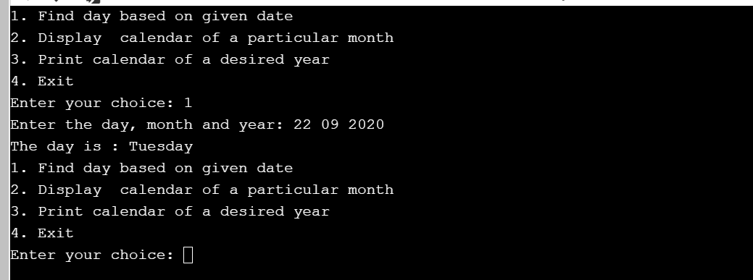

2.You can find the month calendar by entering the month and year. For example, if you enter month = 09 and year = 2020, it gives you the overall september month.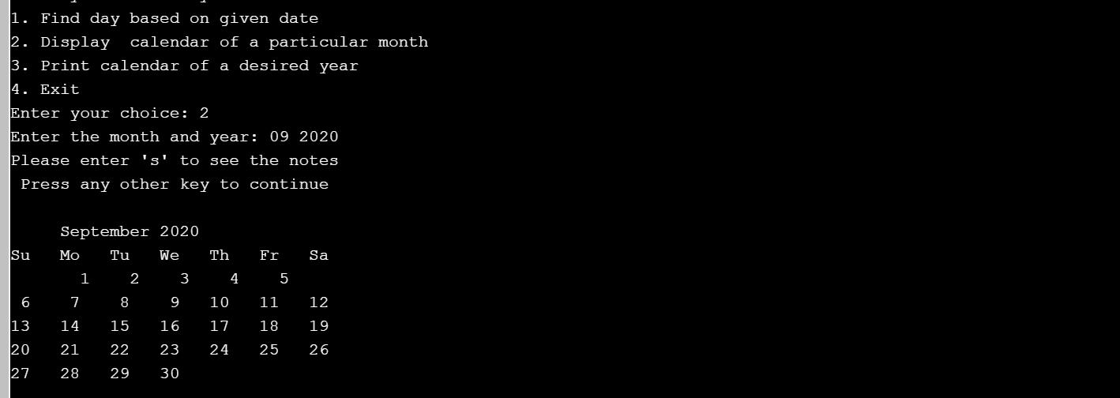

3.You can find the entire year calendar by entering the year.It displays a nicely formatted calendar of every month of that particular year.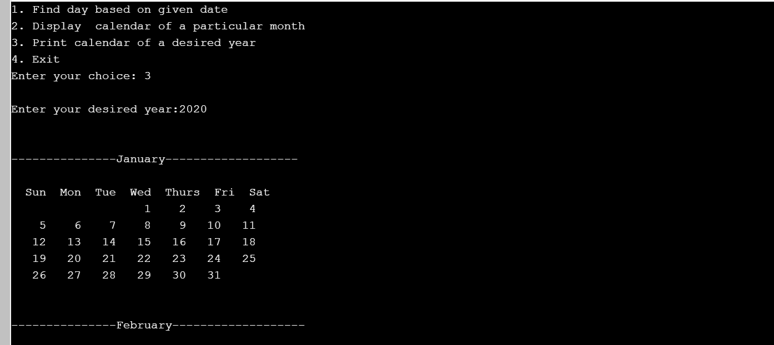

4.If you want to exit from the loop choose option 4 to exit and it displays “bye!!”.